Using StatCrunch to Generate Random Numbers

1) Select 🡪 Simulate 🡪 Discrete Uniform

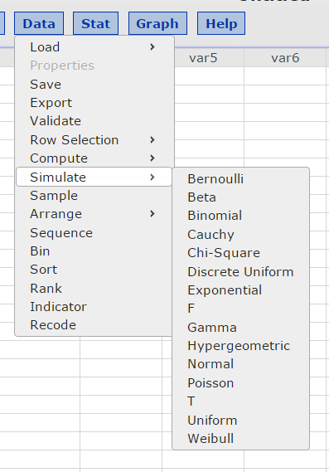

2) Select 40 rows as you can’t use the same word more than once. Select the first unique 20 numbers to use to collect your random sample of words from the story.

